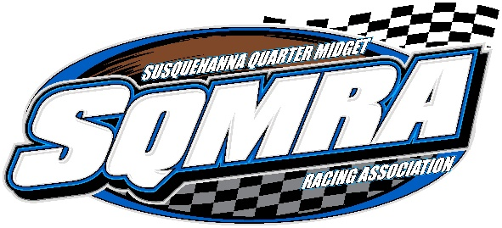

Sponsorship Request Letter

Dear Business Owner:
Let me take this opportunity to introduce you to the Susquehanna Quarter Midget Racing Association (SQMRA). We are a newly formed non-profit organization with our racetrack located at Baps Motor Speedway in York Haven, PA. Our drivers range in age from 5 to 16 years old. Our goal is to give today’s young drivers a place to race, while ensuring they grow as a driver and person. Quarter Midget racing is definitely a family sport, not only do the kids learn motor skills and strengthen their coordination, they also learn life lessons such as sportsmanship, discipline, independent thinking and effective communication.
We would like to extend the opportunity to your business to become a track sponsor. Your support will help us grow the track into one of the premier youth racing venues on the east coast. We have many different sponsorship options ranging in amounts of $250 and up. Please review the sponsorship options we are presenting. We are also excited to offer custom packages tailored to your business specifically. We would love nothing more than to promote a race embracing your business and making your service and/or products and turning that into a theme for that race.
SQMRA is an organization run by volunteers that have the kid’s best interests at heart. Our goal is to raise money to provide them with a great venue to race and follow their dreams. We have several mentoring and teaching events planned that we would like to see happen for our kids. Our primary source of funds is membership fees and registration fees paid by the families that race. These fees, many times, doesn’t cover the expenses so it’s vital for us to partner with businesses like yourself.
Please take a moment to review and select the sponsorship package that best fits your business and budget.
Respectfully yours,

Brandin Ort
SQMRA President
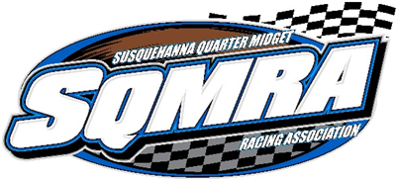

2020 Sponsorship Packages

The Platinum Package:
Your name, or that of your business, will be engraved on over 30 trophies, which are presented to those drivers who finish in the top 3 spots in each divisions feature race event that evening. Your name as the sponsor of the event will be announced over the public address system periodically throughout the racing program.
- Your name on a 2′x4′ billboard sign which is prominently displayed for the entire season.
- 2 Tickets to our Annual Banquet
- A Wall Plaque in recognition of your sponsorship
Maximum Exposure for your business for $750.00.

The Gold Package:
Your name, or that of your business, will be engraved on over 30 trophies, which are presented to those drivers who finish in the top 3 spots in each divisions feature race event that evening. Your name as the sponsor of the event will be announced over the public address system periodically throughout the racing program.
Great Exposure for a cost of $500.00
​
​Billboard Sponsor:
Have your Company’s name on a 2′x4′ billboard for the entire season, giving you exposure every week!
$250.00 New Sign.

Sponsorship Selection Form
The sponsorship year runs from January 1st, 2020 until December 31st, 2020. Please consider making your selection below and returning it with your sponsorship donation today. Upon receipt, we will contact you for information regarding your advertisements and/or logo.
Levels:
_______Platinum Package
_______Gold Package
_______Billboard Package

Total Donation____________________________

Please choose your sponsorship level above and mail with check to the address below.

Sponsor Contact:_______________________________________________________
Business Name:________________________________________________________
Street Address:_________________________________________________________
City/State/Zip Code:_____________________________________________________
Phone:_____________________________________
Email Address:_____________________________

Please make checks payable to SQMRA & mail to:
Kris Ruppert 772 Heck Hill Rd. Lewisberry, PA 17339
For Additional Information or Questions Please Contact:
Brandin Ort, President SQMRA @ 717-855-6851.

